Chapter 10 Chemical Equilibrium name: class:
考点 A: 可逆反应与平衡 Reversible Reactions and Equilibrium
大多数物理和化学过程可逆，正向和逆向同时进行
平衡特征：无宏观变化、反应物和产物共存、浓度/分压恒定
动态平衡：正逆反应速率相等

1. Which statement below best describes a dynamic equilibrium? （ ）
A. The rate of the forward reaction is equal to the reverse reaction, and the concentrations of reactants and products is constant
B. The rate of the forward reaction is equal to the reverse reaction in a closed system, and the concentrations of the reactants and products are equal
C. The rate of the forward reaction is equal to the reverse reaction in a closed system, and the concentrations of the reactants and products is constant
D. The rate of reaction changes in either direction to counteract a change in conditions

2. When a chemical reaction reaches equilibrium which of the following can be said about the concentrations of the substances present, and the rates of reaction? （ ）
A. The concentrations of the reactants and products continue to change and the rates of forward and reverse reactions remain the same.
B. The concentrations of the reactants and products remains constant and the rates of forward and reverse reactions remain the same.
C. The concentrations of the reactants and products continue to change and the rates of forward and reverse reactions are different.
D. The concentrations of the reactants and products remain constant and the rates of forward and reverse reactions are different.

图 C₁0-1：可逆反应正逆速率随时间变化（对应考点 A MCQ3）
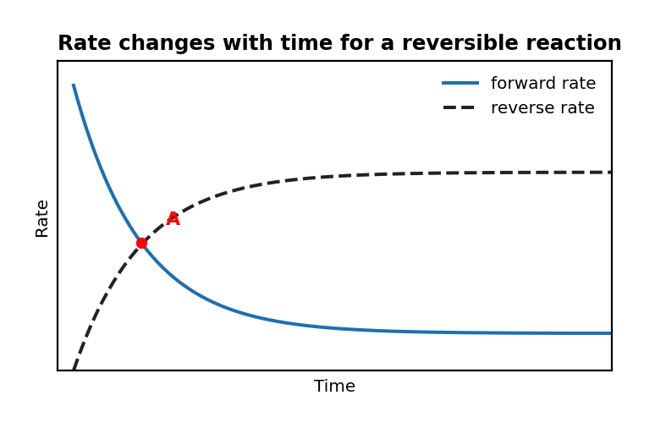

3. The graph above shows how rate changes with time for a reversible reaction.
Which of the following is not correct about point A? （ ）
A. The rate of the forward and reverse reaction reactions remain constant.
B. Partial pressures remain constant
C. The number of particles of each species remains constant
D. The concentrations of reactants and products are equal

4. N₂O₄ (g) ⇌ 2NO₂ (g) A sealed container with a volume of 2.0 L contains 2.0 atm of N₂O₄ (g) at a constant temperature 350 K.
The gas decompose according to the reaction.
The partial pressures of 2NO₂ (g) over time are recorded in the table below:
Time elapsed (s) Partial pressure N₂O₄ (atm) Partial pressure NO₂ (atm)₀₂.000.00201.850.30401.700.60601.600.80801.550.901001.550.90 Based on the data, what claim can be made about the system? （ ）
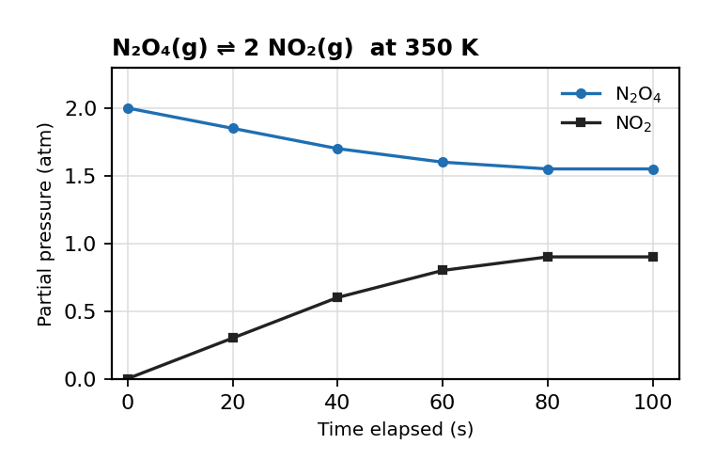
图 C₁0-2：N₂O₄ ⇌ 2 NO₂ 分压随时间变化（对应考点 A MCQ4）
A. The system is at equilibrium after 60 seconds because the pressure of N₂O₄ is decreasing.
B. Equilibrium is reached after 80 seconds because the pressures of both gases remain constant.
C. The forward and reverse reactions are still occurring but at unequal rates between 60 and 80 seconds.
D. The system is at equilibrium after 100 seconds because the forward reaction has stopped.

5. C₂H₆ (g) ⇌ C₂H₄ (g) + H₂ (g) The reaction above occurs in a 1.0 L sealed container at 500 K.
Initially, 0.050 M of C₂H₆ (g) is introduced into the container.
The following data show the concentration of H₂ (g) over time:
Time elapsed (s) Concentration of H₂ (M) 00.00400.012800.0191400.0222000.0253000.0274000.0275000.027 Based on the data, what claim can be made about the system? （ ）
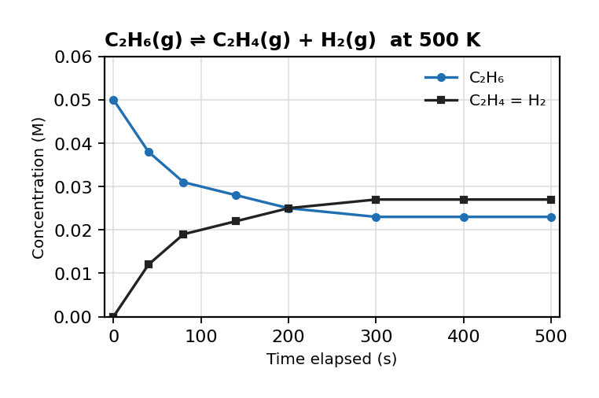
图 C₁0-3：C₂H₆ ⇌ C₂H₄ + H₂ 浓度随时间变化（对应考点 A MCQ5）
A. Equilibrium was established between 200 and 300 seconds because the concentration of ​ H₂ (g) stopped changing.
B. The forward reaction stops after 300 seconds because all of the C₂H₆ (g) has decomposed.
C. Equilibrium has not been reached because the concentration of ​ H₂ (g) ​ is less than 50% of the starting C₂H₆ (g).
D. It is not possible to determine equilibrium without knowing the concentration of ​C₂H₆ (g).

6. PCl₅ (g) ⇌ PCl₃ (g) + Cl₂ (g) When sample of PCl₅ (g) is introduced into a sealed container at 673 K the above reaction occurs.
The system is observed carefully for changes in pressure, color, and concentration.
Which of the following observations would provide the strongest evidence that the system has reached equilibrium? （ ）
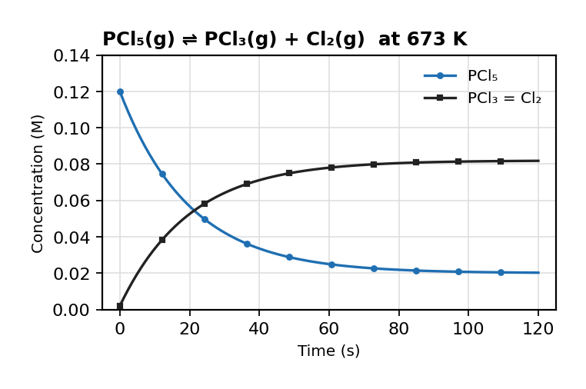
图 C₁0-4：PCl₅ ⇌ PCl₃ + Cl₂ 浓度随时间变化（对应考点 A MCQ6）
A. The total pressure in the container increases steadily as PCl₅ (g) decomposes.
B. The concentration of Cl₂ (g) continues to increase as PCl₅ (g) decreases steadily.
C. The color of the system fades to colorless as PCl₅ is converted into PCl₃ (g) and Cl₂ (g)
D. The pressure in the container becomes constant.

考点 B: 反应商与平衡常数 Q and K
1. 掌握平衡常数 Kc / Kp 和 ICE 表格
aA + bB ⇌ cC + dD: Kc = [C]^c[D]^d / [A]^a[B]^b (products over reactants)
Only gases and aqueous species appear in K expression; solids and pure liquids do NOT
反应商 Q_c 描述任意时刻浓度比值（气体可用 Q_p）
K 值大小表示平衡倾向：K>>1 倾向产物，K<<1 几乎不反应
K 的数学变换：方程式反向→K 取倒数；系数乘 n→K 的 n 次方；方程式相加→K 相乘
K 的性质（仅与温度有关，与浓度/压力无关）
3. 掌握 Q vs K —— 判断反应方向
Q (reaction quotient): same form as K but using initial/current concentrations
Q < K → proceeds forward; Q > K → proceeds reverse; Q = K → at equilibrium

1. For 2SO₂ + O₂ ⇌ 2SO₃, Kc=4.0×10². At a given moment: [SO₂]=0.050, [O₂]=0.025, [SO₃]=0.500. Q = 4.0×10³. （ ）
A Reaction proceeds forward (Q < K).
B Reaction proceeds reverse (Q > K).
C System is at equilibrium.
D More information needed.

2. 2NOCl (g) ⇌ 2NO + Cl₂ (g) Nitrosyl chloride decomposes into nitrogen monoxide and chlorine according to the equation above.
What is the correct formulation of the equilibrium expression of the reaction? （ ）
A. Kc = [HI]²/([H₂][I₂]) (products over reactants, coefficients become powers)
B. Equation B
C. Equation C
D. Equation D

3. 3O₂ (g) ⇌ 2O₃ (g) What is the value of the equilibrium constant when the equilibrium concentrations are [O₂] = 0.8 M and [O₃] = 0.8 M ? （ ）
A. Option A
B. Option B
C. Option C
D. Option D

4. The equilibrium reaction below has an equilibrium constant K = 1.1: X(g) ⇌ Y(g).
Based on the value of K, which of the following must be true? （ ）
A. Option A
B. Option B
C. Option C
D. Option D

5. The reaction N₂ (g) + 3H₂ (g) 2NH₃ (g) has an equilibrium constant value of 2.7 x10³ at a certain temperature What is the equilibrium constant of 4NH₃ (g ) 2N₂ (g) + 6H₂ (g)? （ ）
A. Option A
B. Option B
C. Option C⁻⁷
D. Option D⁻⁴

6. A (g) + 2B (g) ⇌ X (g) + Y (g) The reaction above has a value of Kp = 1.0 x10-4 at 25 C.
Which of the following relationships is correct about this equilibrium at 25 C? （ ）
A. The partial pressure of A will be equal to the partial pressure of Y
B. The partial pressure of A will be greater than the partial pressure of X
C. The partial pressure of A will be less than the partial pressure of Y
D. The partial pressure of B will be equal to the partial pressure of Y

7. The reaction between nitrogen and hydrogen produces ammonia gas: N₂ (g) + 3H₂ (g) 2NH₃ (g) If the equilibrium constant for the reaction is x, what is the equilibrium constant for the following reaction? 2N₂ (g) + 6H₂ (g) 4NH₃ (g) （ ）
A. Option A
B. Option B
C. Option C
D. Option D

8. Consider the following reaction at different temperatures.
The equilibrium constant (K) values were measured at each temperature:
TemperatureKc valueT11 x10-2T21 x10¹T31T41 x10² Which of the following correctly ranks the amount of products in the equilibrium mixtures from least to most? （ ）
A. Option A
B. Option B
C. Option C
D. Option D

9. Consider the following two equilibrium reactions: 2NOBr (g) ⇋ 2NO (g) + Br₂ (g), with equilibrium constant Kc₁ NO (g) + Br₂ (g) ⇋ NOBr (g), with equilibrium constant Kc₂ Which of the following is the correct mathematical relationship between Kc₁ and Kc₂​? （ ）
A. Option A
B. Option B
C. Option C
D. Option D

10. Which of the following conclusions can be made about this reaction? H₂O (g) ⇋ H₂ (g) + O₂ (g) Kc = 8 x10-41 at 25 C （ ）
A. The reaction does not proceed.
B. The reaction goes almost to completion.
C. The products have a higher concentration than the reactants.
D. The concentrations of reactants and products are the same.

11. 2CO₂ (g) ⇌ 2CO (g) + O₂ (g) Kc = 31.2 at 298 K Which of the following is true for the above reaction when the concentration of the reactants and products are: [CO₂] = 2.0 x10⁻³ M[CO] = 0.015 M[O₂] = 0.010 M （ ）
A. The reaction will move to the right to achieve equilibrium.
B. The reaction will move to the left to achieve equilibrium.
C. Option C
D. Option D

12. The value of Kc at 298K for the following reaction is 4.0: CH₃COOH (aq) + CH₃CH₂OH (aq) ⇋ CH₃COOCH₂CH₃ (aq) + H₂O (aq) A student measures the concentrations and calculates a value for the reaction quotient, Q=8.7.
What does this tell you about the system? （ ）
A. The reaction has not reached equilibrium and is moving left to right.
B. The reaction has not reached equilibrium and is moving right to left.
C. The reaction has reached equilibrium, but there are more products than reactants.
D. The reaction has reached equilibrium, but there are more reactants than products.

考点 C: 平衡浓度计算 Calculating Equilibrium Concentrations
ICE table: Initial → Change → Equilibrium; K is constant at given T

1. H₂ + I₂ ⇌ 2HI at 700K. 2.00L flask, initial 0.500 mol H₂ and 0.500 mol I₂. At eq: [HI]=0.390 M.
(a) Write the Kc expression. [1 mark]
(b) Calculate equilibrium [H₂] and [I₂]. [2 marks]
(c) Calculate Kc. [2 marks]

2. PCl₅(g) ⇌ PCl₃(g) + Cl₂(g), Kp=1.78 at 500K. Initial PCl₅=2.00 atm, no PCl₃ or Cl₂.
(a) Set up ICE and solve for equilibrium pressures. [4 marks]

1. 2N₂O₅ (g) ⇌ 4NO₂ (g) + O₂ (g) When gaseous dinitrogen pentoxide, N₂O₅ (g), decomposes at 358 K, the equilibrium above is established. 2.0 mol of N₂O₅ (g) were placed in a 1.0 L container and allowed to reach equilibrium.
At equilibrium 1.0 mol of N₂O₅ (g) were present.
What is the value of Kc? （ ）
A. Option A
B. Option B
C. Option C
D. Option D

2. Consider the following equilibrium reaction: 2NO (g) + 2H₂ (g) N₂ (g) + 2H₂O (g) Initially, the following concentrations were present in a 1.0 L flask: [NO] = 0.20 mol / L[H₂]=0.08 mol / L[H₂O]=0.10 mol / L At equilibrium, the concentration of H₂​ is found to be 0.02 mol/L.
What is the value of the equilibrium constant for this reaction? （ ）
A. Option A⁻²
B. Option B
C. Option C
D. Option D

3. For the reaction A₂ (g) + B₂ (g) ⇌ 2AB (g) What can be deduced about the value of Kp? （ ）
A. Option A
B. Option B
C. Option C
D. Using the data nothing can be concluded about the value of Kp.

4. For the reaction: X₂ (g) + Y₂ (g) ⇌ 2XY (g) The following represents the ratio of molecules at equilibrium at 25 °C in a 1.00 L sealed container.
Assume that each particle in the diagram represents 1 mole.
Based on this information, what is the equilibrium constant, Kc, for the reaction above at 25°C? （ ）
A. Option A
B. Option B
C. Option C
D. Option D

5. 2SO₃ (g) ⇌ 2SO₂ (g) + O₂ (g) Kc = 1.7 x10-18 at 300 K If the concentration of SO₃ (g) was 0.060 M.
What is the concentration of O₂ (g) at equilibrium? （ ）
A. Option A
B. Option B⁻²¹ M
C. Option C⁻⁷ M
D. Option D⁻⁷ M

6. PCl₃ (g) + Cl₂ (g) ⇌ PCl₅ (g) Kc = 50 at 450 oC If the initial concentration of PCl₃ was 0.30 M and Cl₂ was 0.45 M, what is the concentration of PCl₅ at equilibrium? （ ）
A. Option A
B. Option B
C. Option C
D. Option D

7. Br₂ (g) + Cl₂ (g) ⇌ 2BrCl (g) Kp = 70 at 400 K 3.0 atm of Br₂ (g) and Cl₂ (g) are mixed in a sealed container at 400 K and left to reach equilibrium.
Which expression is the most appropriate to calculate the partial pressure of BrCl (g) at equilibrium? （ ）
A. Pᵢ = (nᵢ/RT) × V_total (incorrect dimension analysis)
B. Option B
C. Option C
D. Option D

考点 D: 勒夏特列原理 Le Chatelier's Principle
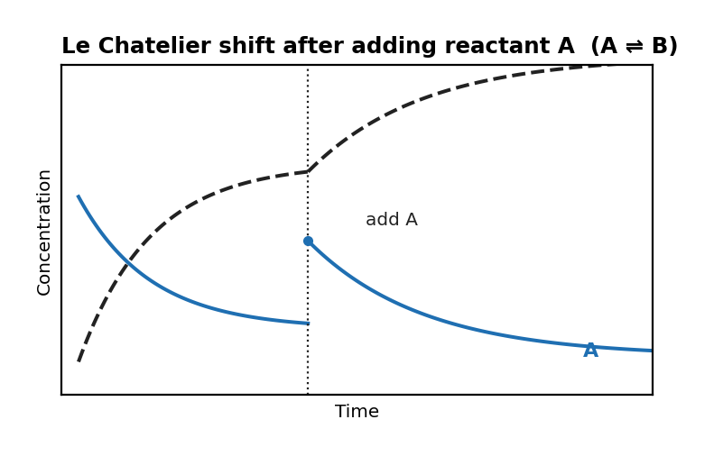
图 C₁0-5：Le Chatelier 原理示意图——加入反应物后平衡移动（对应考点 D）
2. 掌握 Le Chatelier 原理
When a system at equilibrium is disturbed, it shifts to partially counteract the disturbance
Add reactant → shift →; Add product → shift ←; Increase T for endothermic → shift →; Increase P → shift to fewer moles of gas

1. N₂O₄(g) ⇌ 2NO₂(g) has ΔH°=+57.2 kJ/mol. Increasing T will: （ ）
A shift equilibrium right, increasing K.
B shift equilibrium left, decreasing K.
C have no effect if pressure is constant.
D shift equilibrium right, K unchanged.

2. CO(g) + 2H₂(g) ⇌ CH₃OH(g). Decreasing the volume at constant T will: （ ）
A increase moles of CH₃OH (fewer gas molecules favored).
B decrease moles of CH₃OH.
C have no effect.
D increase moles of CO.

3. PCl₅ (g) ⇌ PCl₃ (g) + Cl₂ (g) has Kp = 1.78 at 500 K. A mixture of PCl₅ (g), PCl₃ (g), and Cl₂ (g) is at equilibrium in a container at 500 K.
The volume of the container is suddenly halved while the temperature is held constant at 500 K.
Which of the following will most likely occur as the system returns to equilibrium? （ ）
A. The partial pressure of PCl₅ (g) will remain constant.
B. The forward reaction is favored.
C. Option C
D. The reverse reaction is favored.

4. Fe₃+ (aq) + SCN- (aq) ⇋ [FeSCN]2+ (aq) Kc = 140 at 298 K The blood-red complex iron(III) thiocynanate, [FeSCN]2+ is formed when yellow iron(III) ions react with thiocyanate ions.
Which of the following will occur if Fe(NO₃)₃ (aq) ions are added? （ ）
A. The concentration of Fe₃+ (aq) ions will increase.
B. The solution will turn darker.
C. The solution will turn paler.
D. The equilibrium constant, Kc, will decrease.

5. The blood-red complex iron (III) thiocynanate, [FeSCN]2+, is formed when yellow iron (III) ions react with colorless thiocyanate ions in the following equilibrium reaction:
Fe₃+ + SCN- ⇋ [FeSCN]2+ ΔHᶿ = +12 kJ Which of the following changes would shift the equilibrium to make the solution lighter? （ ）
A. Raising the temperature of the solution.
B. Lowering the temperature of the solution.
C. Adding iron(III) chloride solution.
D. Adding thiocyanate ions.

6. The Haber process is a key step in the manufacture of fertilizers: N₂ (g) + 3H₂ (g) 2NH₃ (g) ΔH = -ve How does increasing the temperature affect the equilibrium and the equilibrium constant (Kc​)? （ ）
A. Shifts equilibrium to the left; Kc​ decreases.
B. Shifts equilibrium to the right; Kc​ increases.
C. Shifts equilibrium to the left; Kc​ remains unchanged.
D. Shifts equilibrium to the right; Kc remains unchanged.

7. Consider the following equilibrium reaction: H₂ (g) + I₂ (g) ⇋ 2HI (g) ΔHᶿ = -126 kJ Which of the following changes will increase the concentration of hydrogen iodide (HI)? （ ）
A. Increase temperature (exothermic reaction), increase pressure (two moles of gaseous product but only one mole of each gaseous reactant).
B. Increase temperature (endothermic reaction), no change in pressure (equal numbers of moles of gases).
C. Decrease temperature (exothermic reaction), decrease pressure (two moles of gaseous product but only one mole of each gaseous reactant).
D. Decrease temperature (exothermic reaction), no change in pressure (equal numbers of moles of gases).

8. Nitrogen dioxide can react with itself to produce a dimer molecule called dinitrogen tetroxide in the following equilibrium reaction: 2NO₂ (g) ⇋ N₂O₄ (g) Kc = 0.01 at 25 C In an experiment, 100 mL of nitrogen dioxide is placed in a gas syringe, and the barrel is pushed in, meaning the volume is reduced to 50 mL at constant temperature.
How will the equilibrium respond? （ ）
A. More N₂​O₄​ will form.
B. Option B
C. The value of Kc​ will increase.
D. The equilibrium will remain unchanged.

考点 E: 平衡与热力学 Equilibrium and Thermodynamics
ΔG = ΔG° + RT ln Q
ΔG° = −RT ln K
K>1 ↔ ΔG°<0 热力学上有利
考点 F: 沉淀溶解平衡 Solubility Equilibria
4. 掌握溶度积 Ksp 和沉淀判断
Ksp = [cation]^a[anion]^b for sparingly soluble salt; molar solubility s and Ksp are related
Precipitate forms if Q > Ksp; Common ion effect: solubility decreases when a common ion is present

1. CaF₂(s) ⇌ Ca²⁺ + 2F⁻, Ksp=3.9×10⁻¹¹.
(a) Calculate molar solubility in pure water. [2 marks]
(b) Calculate molar solubility in 0.050 M NaF. [3 marks]

1. AgCl is less soluble in 0.10 M NaCl than in pure water because: （ ）
A NaCl reacts with AgCl.
B the common ion Cl⁻ shifts equilibrium left (common ion effect).
C NaCl increases the temperature.
D AgCl is more soluble in salt water.

2. The correct form of the solubility product for calcium phosphate, Ca₃(PO₄)₂, is （ ）
A. Option A
B. Option B
C. Option C
D. Option D

3. For the following reaction at equilibrium 2HF (aq) + Ca₂+ (aq) ⇌ CaF₂ (s) + 2H+ (aq) ΔH < 0 The reaction occurs in an aqueous solution, and CaF₂ precipitates as a solid.
Which of the following changes will result in more CaF₂ being produced? （ ）
A. Adding sodium hydroxide.
B. Decreasing the pressure.
C. Option C
D. Increasing the temperature.

4. Ca(NO₃)₂ + K₂SO₄ → CaSO₄ + 2KNO₃ Ksp = 2.00 x10-5 at 298 K 100 mL of a 1.70 x10-3 M solution of calcium nitrate is slowly added to 100 mL of 1.50 x10-3 M potassium sulfate.
Which of the following will be observed? （ ）
A. A precipitate forms because Q > Ksp
B. A precipitate forms because Q < Ksp
C. No precipitate forms because Q > Ksp
D. No precipitate forms because Q < Ksp

5. A saturated solution of Sr(OH)₂ has a pH of 12.50. What is the solubility product of Sr(OH)₂? （ ）
A. Option A⁻⁵
B. Option B⁻⁵
C. Option C⁻³⁸
D. Option D⁻⁴

6. The solubility of silver carbonate (Ag₂CO₃) in pure water at 25∘C is found to be 1.27×10−4 M.
If 0.100 M of sodium carbonate (Na₂CO₃) is added to the solution, what is the new solubility of Ag₂CO₃ assuming the solution reaches equilibrium?
The Ksp of Ag₂CO₃ at 25∘C is 8.1×10−12. （ ）
A. Option A
B. Option B
C. Option C
D. Option D

